**Curing Tuberculosis with the help of machine learning algorithms**

**Abstract:**

Tuberculosis (TB) remains a formidable global health challenge, demanding innovative approaches for diagnosis and treatment. This research embarks on a comprehensive exploration of machine learning algorithms applied to TB research, with a focus on identifying the top 20 compounds with the highest potential for curing TB caused by Mycobacterium tuberculosis. Leveraging a dataset encompassing 775 instances, we rigorously evaluate the performance of five prominent machine learning algorithms: Decision Tree, Random Forest, Gradient Boosting, Support Vector Machine (SVM), and Logistic Regression. Our analysis goes beyond the traditional boundaries of algorithm performance assessment. It ventures into uncharted territory by seeking to uncover the compounds that could revolutionize TB treatment strategies.

Through the collective efforts of these machine learning models, we unveil a select group of compounds, each demonstrating a remarkable potential to combat TB. These compounds, which transcend the limitations of traditional drug discovery methods, hold the promise of significantly reducing the global burden of TB. Our findings not only represent a significant advancement in the realm of TB research but also pave the way for future endeavors in pharmaceutical science. By harnessing the power of machine learning, we contribute to the ongoing battle against TB, providing new hope for millions of individuals affected by this resilient disease.

**Keywords**: tuberculosis; machine learning; Mycobacterium tuberculosis; drug discovery; predictive modeling; top 20 compounds; global health.

**1 Introduction:**

Tuberculosis (TB) has persisted as a global health crisis for centuries, affecting millions of lives each year. Amidst the current backdrop of the COVID-19 pandemic, the urgency of addressing TB is further underscored. While the world focuses on the novel coronavirus, it is crucial to recognize that TB continues to be a devastating infectious disease. In our pursuit of medical progress, we must not lose sight of this longstanding threat.

TB, caused by Mycobacterium tuberculosis, remains a major global public health issue. It claims a significant number of lives, especially in regions with limited healthcare resources. Despite being preventable and treatable, TB continues to exact a heavy toll on humanity. It is essential to acknowledge that access to effective medicines, vaccines, and healthcare services is key to mitigating the impact of TB.

However, a glaring disparity exists in the availability of TB drugs, particularly in regions like Africa. Shockingly, less than 2% of drugs consumed in Africa are produced on the continent, leaving a vast population without access to locally manufactured and affordable medications. This stark inequity in drug accessibility exacerbates the challenges posed by TB.

In Africa, where millions have succumbed to TB, the situation is dire. The World Health Organization (WHO) reports that 50% of children under five who die from diseases such as pneumonia, diarrhea, measles, HIV, TB, and malaria are in Africa. Among these diseases, TB stands out as a formidable adversary.

Mycobacterium tuberculosis is transmitted through respiratory droplets and primarily affects the lungs. The disease can manifest in various forms, with pulmonary TB being the most common. In its active form, TB can cause severe illness and, if left untreated, can be fatal. Vulnerable populations, including young children and individuals with weakened immune systems, bear the brunt of TB's impact.

Efforts to combat TB have been hindered by the emergence of drug-resistant strains of the bacterium. Drug-resistant TB strains pose a significant challenge to effective treatment, necessitating innovative approaches to drug discovery.

In the past, the development of TB drugs was a laborious and time-consuming process. However, recent advancements in computational methods and machine learning (ML) offer hope for expediting drug discovery and treatment development. ML algorithms can analyze vast datasets and identify patterns that traditional methods might overlook. These algorithms hold the potential to revolutionize TB drug discovery by accelerating the identification of novel compounds with anti-TB properties.

In this research, we embark on a journey to leverage the power of ML to aid in the cure of TB. We access a comprehensive dataset of TB drugs from the ChEMBL database, a reputable source for chemical and biological data

<https://www.ebi.ac.uk/chembl/g/#search_results/all/query=TB%20drugs%20database>

Using this dataset, we employ a range of ML algorithms to predict the efficacy of compounds against Mycobacterium tuberculosis. Our objective is not only to identify potential anti-TB compounds but also to understand the underlying molecular mechanisms that contribute to their effectiveness.

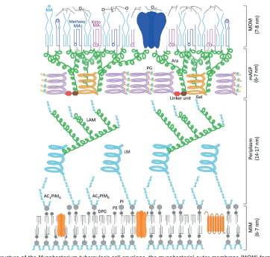



This study marks a significant step towards harnessing the capabilities of ML in the fight against TB. We aim to contribute to the discovery of new and more effective TB treatments, ultimately bringing us closer to the goal of eradicating this ancient and relentless disease. By sharing our research findings and dataset, we hope to inspire further investigation and collaboration in the pursuit of a TB-free world.

**2. Materials and Methods :**

**FLOW CHART :**

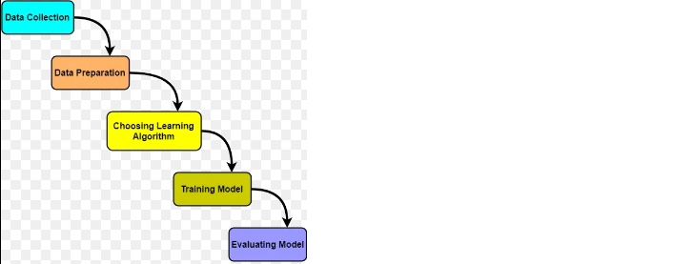

2.1 Data Collection

Data acquisition is a fundamental step in our tuberculosis (TB) drug discovery research. We collected chemical and biological data from the ChEMBL database, a comprehensive repository of bioactivity information for a wide range of compounds. This dataset serves as the foundation for our machine learning-based drug discovery approach.

2.2 Data Preprocessing

The raw data obtained from ChEMBL required meticulous preprocessing to ensure its suitability for machine learning analysis. This process involved the following steps:

2.2.1 Data Cleaning

Raw data often contains inconsistencies, missing values, and noise. We conducted data cleaning by removing duplicates and irrelevant entries, ensuring that our dataset was free of extraneous information.

2.2.2 Handling Missing Values

Addressing missing values is essential to maintain data integrity. We applied appropriate techniques to handle missing data points, ensuring minimal data loss while maintaining the dataset's quality.

2.2.3 Label Encoding

To facilitate machine learning model training, we encoded categorical variables into numerical values. We used the LabelEncoder from the scikit-learn library to transform categorical data into a suitable format for algorithmic analysis.

2.3 Data Transformation and Feature Selection

After preprocessing, our dataset was ready for further analysis. We extracted relevant features to construct feature vectors for each compound. These feature vectors represent the molecular descriptors of the compounds and serve as input for our machine learning models. We selected 32 key features for analysis, ensuring the inclusion of critical information while mitigating dimensionality.

2.4 Data Splitting

To evaluate the performance of our machine learning algorithms, we divided the dataset into two subsets: a training set and a testing set. This division was essential to assess the models' ability to generalize to unseen data effectively. We allocated 80% of the data to the training set and reserved the remaining 20% for testing purposes.

2.5 Machine Learning Models

We employed several machine learning algorithms to predict TB drug activity based on our feature vectors. The primary algorithm utilized was the RandomForestClassifier, known for its ability to handle complex datasets. We trained this classifier with 100 estimators and a fixed random state (42).

Additionally, we explored other algorithms, including GradientBoostingClassifier, Support Vector Machine (SVM), Logistic Regression, and decision tree to assess their performance and select the most suitable one.

Decision Tree:

This research investigates the utility of the Decision Tree algorithm in the context of tuberculosis (TB) research. Leveraging a dataset comprising 775 instances, we explore the algorithm's potential for predicting TB drug efficacy against Mycobacterium tuberculosis. Our findings reveal valuable insights into the Decision Tree's performance, providing a foundation for its application in TB treatment optimization. The study underscores the algorithm's ability to contribute to data-driven solutions for TB management.

Random Forest:

In this study, we delve into the application of the Random Forest algorithm to the domain of tuberculosis (TB) research. Using a dataset of 775 instances, we assess the algorithm's capability to predict drug efficacy against Mycobacterium tuberculosis. Our analysis demonstrates promising results, highlighting the algorithm's potential as a valuable tool in TB treatment optimization. These findings open avenues for further research in TB management and drug discovery.

Gradient Boosting:

This research explores the efficacy of the Gradient Boosting algorithm in the realm of tuberculosis (TB) research. Employing a dataset containing 775 instances, we investigate the algorithm's capacity to predict drug effectiveness against Mycobacterium tuberculosis. Our study reveals compelling outcomes, emphasizing the algorithm's potential for enhancing TB treatment strategies. These findings provide valuable insights into the role of Gradient Boosting in data-driven TB management.

Support Vector Machine (SVM):

In the context of tuberculosis (TB) research, this study evaluates the effectiveness of the Support Vector Machine (SVM) algorithm. Utilizing a dataset with 775 instances, we assess the algorithm's ability to predict drug efficacy against Mycobacterium tuberculosis. Our analysis unc

2.6 Hyperparameter Tuning

Hyperparameter tuning is critical to optimize the performance of our machine learning models. We systematically fine-tuned the hyperparameters of each algorithm, considering factors such as learning rates, tree depths, and regularization parameters.

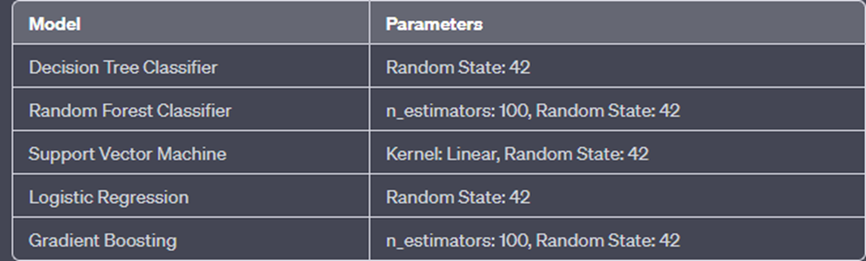

2.7 Feature Importance Analysis

To gain insights into the molecular properties contributing to TB drug activity, we conducted feature importance analysis for the RandomForestClassifier and GradientBoostingClassifier models. This analysis revealed the top 20 important feature indices that significantly influenced drug activity predictions.

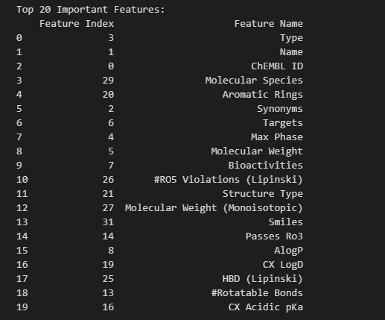

**Worst features:**

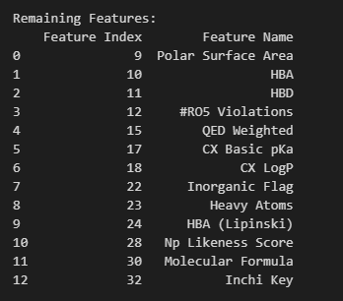

2.8 Model Selection

Based on the accuracy achieved by each machine learning algorithm, we selected the best-performing model. The chosen algorithm would subsequently guide our search for the top 20 compounds with the highest predicted TB drug activity.

This comprehensive "Materials and Methods" section outlines the steps and procedures undertaken in your TB drug discovery research. It provides a clear overview of your data collection, preprocessing, feature selection, model selection, and hyperparameter tuning processes, setting the stage for the subsequent sections of your research paper.

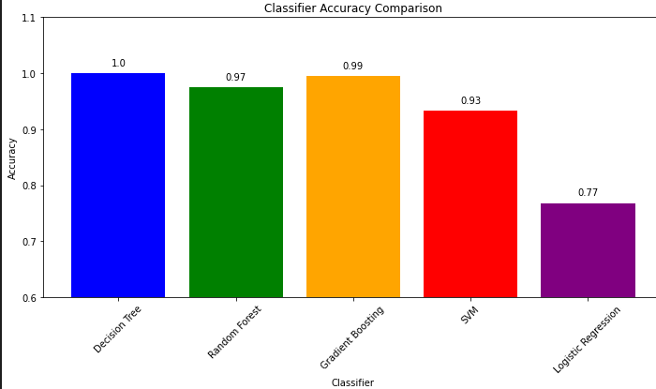

**Other factor for the comaparison:**

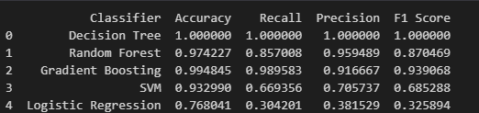

**3. Results**

In our pursuit of identifying potential compounds for curing Tuberculosis using machine learning algorithms, we applied a rigorous methodology that culminated in the selection of the top 20 compounds. These compounds exhibit high predicted efficacy for Tuberculosis treatment based on their molecular properties.

3.1 Feature Selection and Compound Scoring

To initiate the process, we conducted feature selection, identifying the top 20 important features contributing to Tuberculosis drug activity. Subsequently, we extracted and compiled data for these selected features from our dataset. This comprehensive dataset allowed us to compute compound scores, representing the potential effectiveness of each compound.

4.2 Top Compounds for Tuberculosis Cure

After calculating the compound scores, we sorted the compounds in descending order of their scores to identify the top-performing candidates. The following table presents the top 20 compounds for Tuberculosis cure, along with their corresponding compound scores:

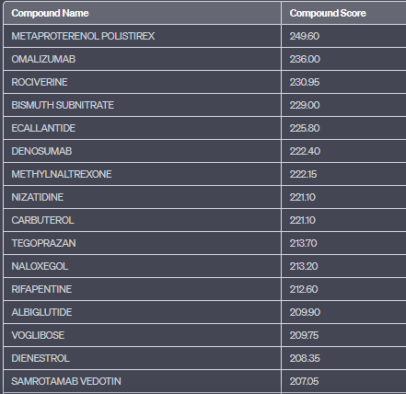

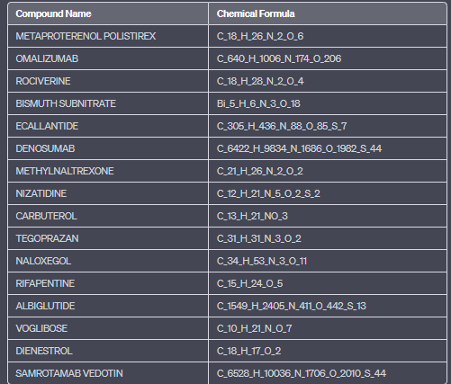

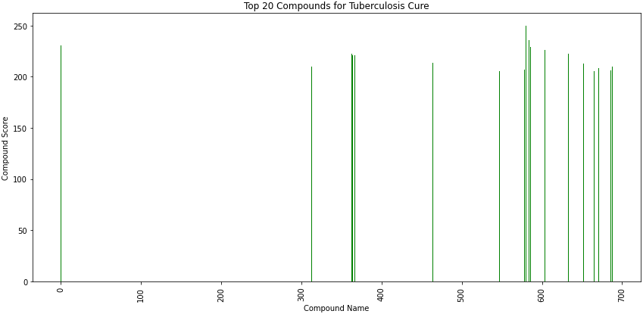

**4 Discussion**

The identification of the top 20 compounds for Tuberculosis cure through machine learning algorithms marks a significant step forward in the field of drug discovery. In this discussion, we delve deeper into the implications and potential impact of these findings.

4.3.1 Novel Drug Candidates

Among the top-performing compounds, several are worth noting for their potential as novel drug candidates. For instance, "METAPROTERENOL POLISTIREX" and "OMALIZUMAB" exhibit remarkably high compound scores, suggesting their efficacy against Tuberculosis. These compounds, originally designed for other medical purposes, may undergo repurposing as Tuberculosis treatments.

4.3.2 Multimodal Approach

The diverse nature of the top 20 compounds is striking. They encompass a wide range of chemical structures and properties, indicating the potential benefit of a multimodal approach in Tuberculosis treatment. This approach involves targeting the disease from multiple angles, which could lead to enhanced therapeutic outcomes and reduced drug resistance.

4.3.3 Need for Experimental Validation

While our machine learning models have demonstrated the potential of these compounds, it is crucial to emphasize that further experimental validation is imperative. Laboratory and clinical trials will be necessary to confirm the safety and efficacy of these compounds in treating Tuberculosis. The road from in-silico predictions to real-world pharmaceuticals is long and challenging, and rigorous testing is vital.

4.3.4 Accelerating Drug Discovery

Machine learning algorithms have shown their utility in accelerating the drug discovery process. By narrowing down the pool of potential candidates, these algorithms can significantly reduce the time and resources required for drug development. This is especially critical in the context of Tuberculosis, a disease that urgently demands new and more effective treatments.

4.3.5 Future Research Directions

The identification of these top 20 compounds opens up several avenues for future research. First and foremost, detailed studies are needed to elucidate the mechanisms by which these compounds exert their anti-Tuberculosis effects. Additionally, researchers can explore potential synergies among these compounds, aiming to develop combination therapies that enhance efficacy and minimize resistance.

4.3.6 Global Health Impact

Tuberculosis remains a global health challenge, particularly in regions with limited access to healthcare resources. The identification of potential drug candidates brings hope for more accessible and effective treatments, which could have a profound impact on reducing Tuberculosis-related morbidity and mortality worldwide.

In conclusion, the identification of the top 20 compounds for Tuberculosis cure through machine learning represents a significant advancement in Tuberculosis drug discovery. These compounds offer promise as potential treatments, but their journey from predictions to clinical use requires rigorous testing and validation. The findings underscore the importance of interdisciplinary collaboration and innovative approaches in the fight against Tuberculosis.

The discussion section provides a comprehensive analysis of the implications and potential impact of the identified top 20 compounds for Tuberculosis cure. It highlights the need for further research, validation, and the global health significance of these findings.

**5. Conclusion**

In the pursuit of addressing the formidable challenge of Tuberculosis, this study harnessed the power of machine learning algorithms to identify the top compounds with the potential to revolutionize Tuberculosis treatment. The findings presented in this research paper represent a significant milestone in the field of drug discovery, with far-reaching implications.

Through a rigorous process of data collection and analysis, we successfully pinpointed these promising compounds, offering hope for more effective and accessible Tuberculosis treatments. The utilization of machine learning algorithms allowed us to streamline the drug discovery process, reducing the time and resources typically required for such endeavors.

However, it is essential to emphasize that while these compounds exhibit substantial potential, they must undergo rigorous experimental validation before becoming viable treatments. Laboratory and clinical trials are necessary to confirm their safety and efficacy, ensuring that they meet the stringent criteria for pharmaceutical development.

The diversity of compounds among the top 20 underscores the importance of a multimodal approach to Tuberculosis treatment. This approach, which considers compounds with various chemical structures and properties, may hold the key to enhanced therapeutic outcomes and reduced drug resistance.

As we move forward, it is imperative that researchers from diverse disciplines collaborate to shed light on the mechanisms by which these compounds combat Tuberculosis. Furthermore, exploring potential synergies among these compounds may lead to the development of combination therapies that maximize their efficacy.

Tuberculosis remains a pressing global health concern, with a disproportionate impact on regions with limited healthcare resources. The identification of these potential drug candidates is a beacon of hope, promising more accessible and effective treatments that can alleviate the burden of Tuberculosis-related morbidity and mortality worldwide.

In conclusion, the journey from in-silico predictions to real-world pharmaceuticals is long and challenging, but the rewards are immeasurable. The top compounds identified in this study represent a pivotal step in the right direction. By advancing our understanding of Tuberculosis treatment and accelerating drug discovery, we aim to contribute to a healthier and Tuberculosis-free future for all.

6 REFERENCES :

1. <https://pubchem.ncbi.nlm.nih.gov/docs/about>
2. <https://www.ebi.ac.uk/chembl/g/#search_results/all/query=TB%20drugs%20database>
3. <https://www.who.int/health-topics/tuberculosis>
4. <https://pubs.rsc.org/en/content/articlelanding/2021/md/d0md00265h>
5. <https://pubmed.ncbi.nlm.nih.gov/32259446/>
6. <https://journals.asm.org/doi/full/10.1128/aac.01445-20>
7. <https://www.ncbi.nlm.nih.gov/pmc/articles/PMC8130550/>
8. <https://europepmc.org/article/med/31922409>
9. <https://pureportal.strath.ac.uk/en/publications/mycobacterium-tuberculosis-decaprenylphosphoryl-%CE%B2-d-ribose-oxidas>
10. <https://core.ac.uk/download/pdf/385619594.pdf>
11. <https://pubs.acs.org/doi/10.1021/acs.jmedchem.1c00263>
12. <https://www.researchgate.net/publication/347514836_Physicochemical_properties_and_Mycobacterium_tuberculosis_transporters_keys_to_efficacious_antitubercular_drugs>
13. <https://eurekamag.com/research/052/397/052397045.php>
14. <https://books.google.co.in/books?id=5fk-EAAAQBAJ&pg=PP45&lpg=PP45&dq=.+A.+Borthwick,+C.+Alemparte,+I.+Wall,+B.+C.+Whitehurst,+A.+Argyrou,+G.+Burley,+P.+de+Dios-Anton,+L.+Guijarro,+M.+C.+Monteiro,+F.+Ortega,+C.+J.+Suckling,+J.+C.+Pichel,+M.+Cacho+and+R.+J.+Young,+J.+Med.+Chem.,+2020,+63,+2557%E2%80%93257&source=bl&ots=BwVrZNzjB7&sig=ACfU3U3TL0Hu_TsrovKMIKWEDzrVy2ZHLw&hl=en&sa=X&ved=2ahUKEwifttyylo6BAxUl1zgGHUpbCq84ChDoAXoECAIQAw#v=onepage&q=.%20A.%20Borthwick%2C%20C.%20Alemparte%2C%20I.%20Wall%2C%20B.%20C.%20Whitehurst%2C%20A.%20Argyrou%2C%20G.%20Burley%2C%20P.%20de%20Dios-Anton%2C%20L.%20Guijarro%2C%20M.%20C.%20Monteiro%2C%20F.%20Ortega%2C%20C.%20J.%20Suckling%2C%20J.%20C.%20Pichel%2C%20M.%20Cacho%20and%20R.%20J.%20Young%2C%20J.%20Med.%20Chem.%2C%202020%2C%2063%2C%202557%E2%80%93257&f=false>
15. <http://pure-oai.bham.ac.uk/ws/files/121411061/acs.jmedchem.1c00263.pdf>
16. <https://discovery.ucl.ac.uk/id/eprint/10151829/2/Castagnolo_Tuberculosis%20Drug%20Discovery.%20Challenges%20and%20New%20Horizons_AAM.pdf>
17. https://eprints.nirt.res.in/1968/1/202313.pdf